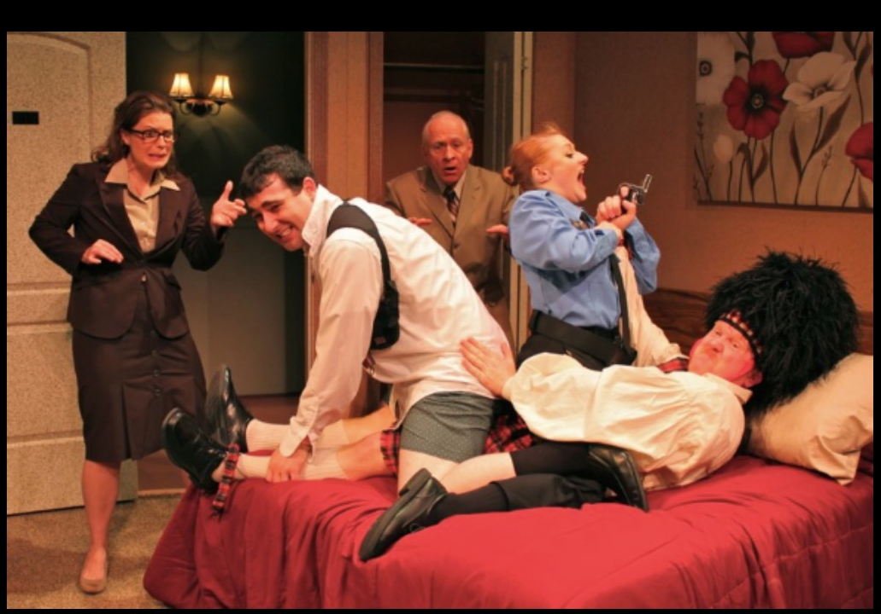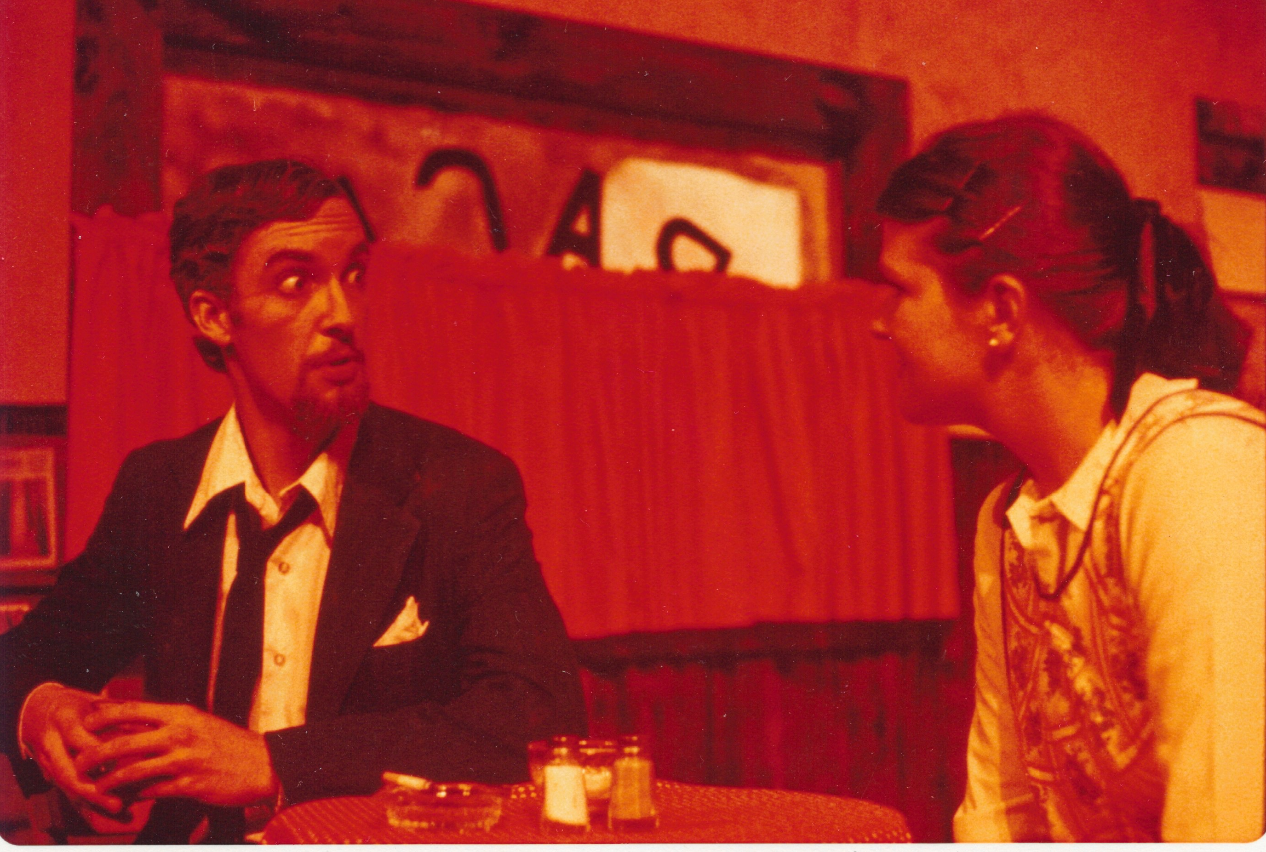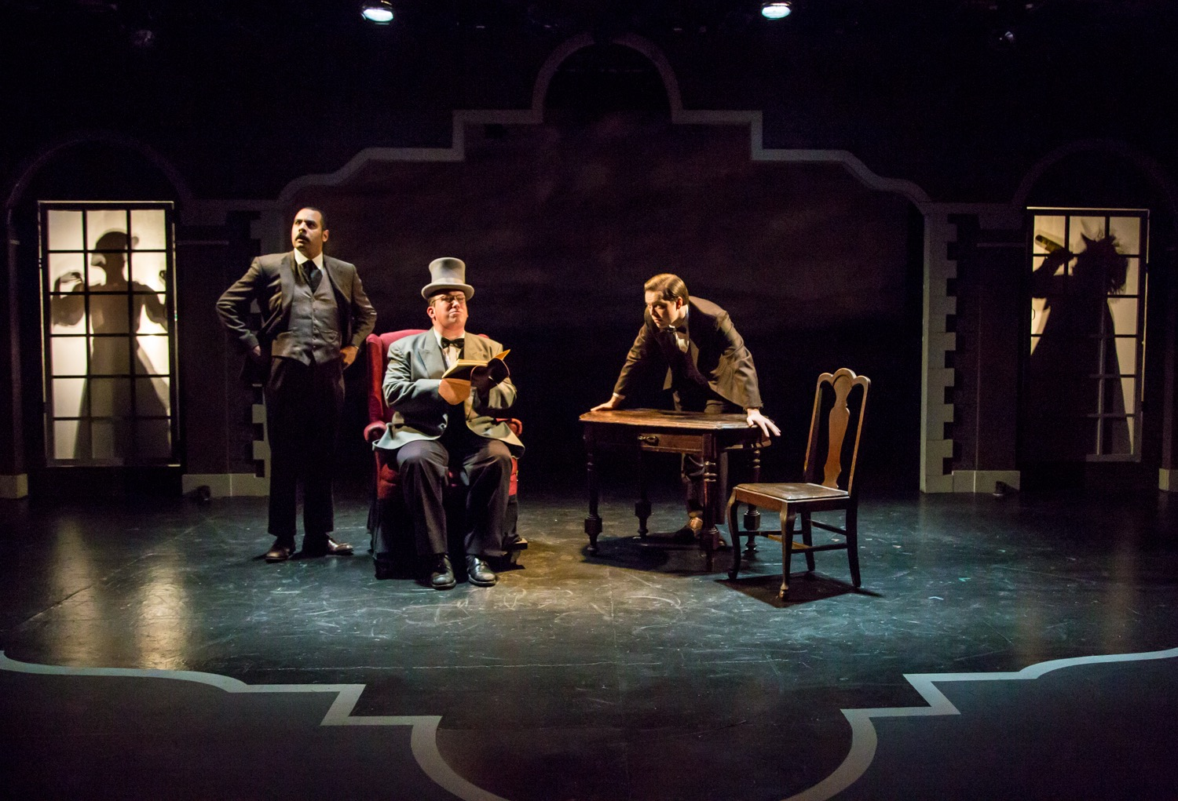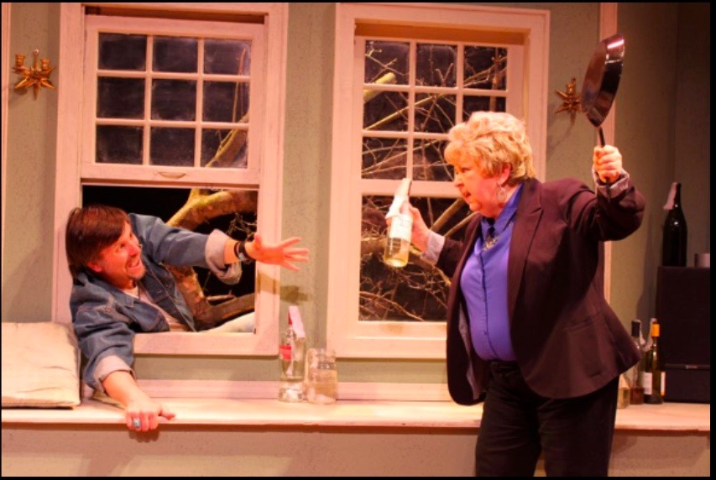
Craig MacDonald - Director
csmacdon57@gmail.com 607-280-1380 http://www.craigmacdonaldactor.com

Selected Directing Credits

Baskerville Cider Mill Playhouse October 2016
The Velocity of Autumn Chenango River Theater May 2015
Unnecessary Farce Chenango River Theater May 2014
Fuddy Meers Syracuse University Drama October 2011
The Art of Dining Syracuse University Drama February 2006
Fully Committed Kitchen Theater, Ithaca, NY September 2003
*Winner - SALT theater award - best performance: Karl Gregory
Caprice (American Premier) Syracuse University Drama March 2002
Cloud Nine Syracuse University Drama April 2000
The Night Larry Kramer.... Syracuse Stage - Cabaret April 1998
Girl Band in the Men’s Room Firehouse Theater, Ithaca, NY January 1997
Of Thee I Sing Ithaca Opera Guild, Ithaca, NY October 1996
Pocahontas, A Daughters Tale Many Faces, Ithaca, NY June 1996
Raven Steals the Light Many Faces, Ithaca, NY November 1995
Bye Bye Birdie New London Barn, NH August 1980
Passion, Poison,... Festival theatre (OOB), NYC May 1979
Roar of the Greasepaint New London Barn, NH July 1979
The Good Doctor New London Barn, NH July 1979
Stop the World.... New London Barn, NH July 1978
Bye Bye Birdie Ithaca College Mainstage November 1977
Bus Stop Fairplayers, Wilton CT August 1977
Arms and the Man Fairplayers, Wilton CT August 1976

MFA – Acting, Rutgers University 1988 BFA - Acting and Directing, Ithaca College 1978

