Craig MacDonald
AEA

607-279-9412
csmacdon57@gmail.com
http://www.craigmacdonaldactor.com

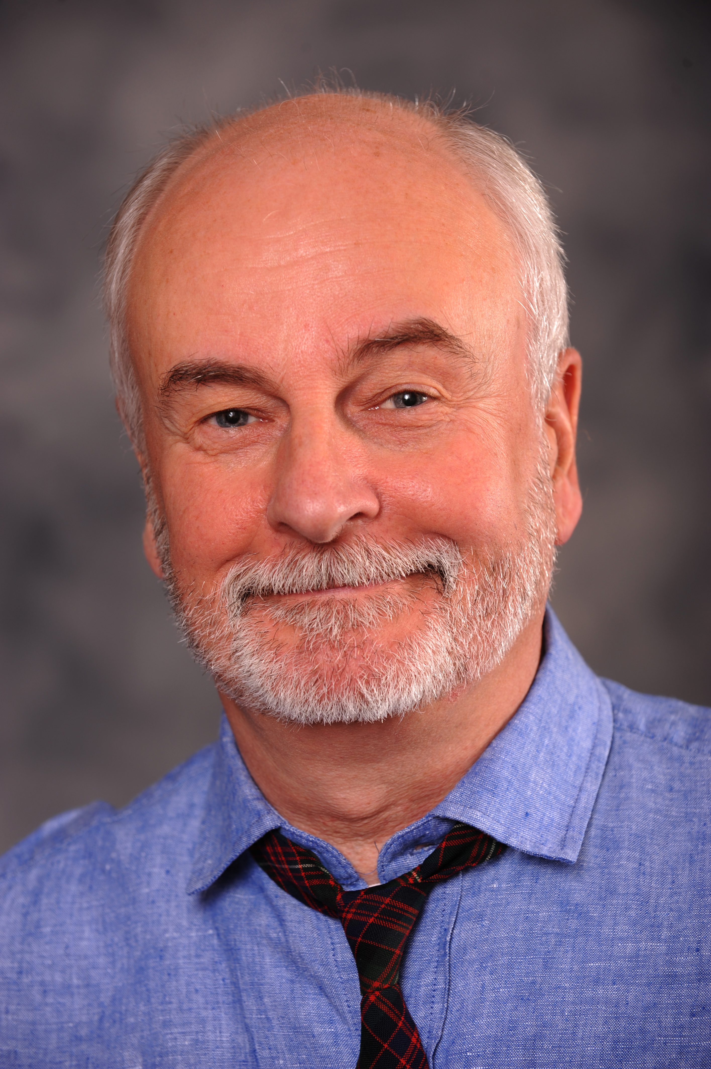

Select Recent Roles

Show Role Theater Director
King Henry VIII Wolsey Valley Shakespeare Tom Simonetti
Finian’s Rainbow Finian McLonergan Olney Theatre Center Christopher Youstra
Once (three productions) Da Pittsburgh CLO Michael Zygo
Olney Theatre Center Marcia Milgrom Dodge
Theatre Squared Amy Herzberg
The Ghost Train Dr. Sterling Centenary Stage Co, Carl Walnau
You Can’t Take It With You Mr. Kirby Hangar Theater Robert Moss
August Osage County Beverly Weston Hangar Theater Beth Milles
Little Women Mr. Lawrence New London Playhouse Chad Larabee
The Crucible Giles Corey Olney Theatre Center Eleanor Holdridge
Rule of Thumb Man without a Finger The Cherry Arts Beth Milles
The Game’s Afoot William Gillette The Ivoryton Playhouse Jacqueline Hubbard
All the Way Richard Russell Theatre Squared Benny Sato Ambush
Urinetown Caldwell Cladwell The Cider Mill Playhouse Emily Jackson
Peter and the Starcatcher Lord Astor Kitchen Theater Rachel Lambert
White Rabbit / Red Rabbit The Actor The Cherry Arts (Sam Buggeln)
The Nether Sims / Papa Centenary Stage Co. Carl Walnau
Woody Guthrie's American… The Writer Shadowland Theatre Chris Blisset
Copenhagen Niels Bohr On the Verge Claire Gleitman
One Man Two Guvnors Harry Dangle Theatre Squared Amy Herzberg
Midsummer... Tom Snout Syracuse Stage Bill Fennelley
The Miracle Worker Mr. Anagnos Syracuse Stage Paul Mason Barnes
Underneath the Lintel The Librarian Theatre Squared Shana Gold
Picasso at the Lapin Agile Gaston Syracuse Stage Penny Metropoulis
King Lear Gloucester Beijing Rep, China Joseph Graves
Hello Dolly Horace VanderGelder Hangar Theater Kevin Moriarity
My Fair Lady Zoltan Karpathy Syracuse Stage Robert Moss
A Christmas Carol Scrooge Kitchen Theater Rachel Lampert
The Good Daughter Matt McCall GeVa Theater Carter Lewis
The Sound of Music Max Detweiler Hangar Theater Kevin Moriarity
Grand View Don Jacobs GeVa Theater Marc Cuddy
The Fantasticks Bellamy Hangar Theater Shawn Countryman
Dracula Van Helsing Syracuse Stage Robert Moss
The Cherry Orchard Gayev Cornell U/RTA Co Bruce Levitt
Macbeth The Porter / Ross Syracuse Stage Ron Bashford
Measure for Measure Duke Vincentio Cornell U/RT/A Co David Feldshuh

Skills: singing (baritone- F2 - F4) multi instrumentalist (guitar, mandolin, ukelele, drums/percussion (bodhran),
dialect coach Spoken languages - Danish and English
Training: MFA Acting - Rutgers (William Esper, Maggie Flanagan) BFA Acting - Ithaca College

